Visit by Bishop James 27th March 2019 – report by Daisy and Chloe Y6

Bishop James came to school today. He was on part of his Cumbria walk and had his walking boots on. He came with Rev Rob and Rev Sarah Moore. Bishop James belongs to the Church of England and Rev Sarah to the URC church. After Collective Worship they both went in to classes in key stage 2 and talked about faith and what salvation means in their churches.
Bishop James knew all about the work we had been doing on Salvation in the lead up to Easter and in the Collective Worship, he talked about soldiers in the First World War who went across the battle field rescuing those who were injured. Bishop James’ story made us all listen really carefully – including the staff. Bishop James ended by explaining that Jesus has done the same thing – rescued lots of people and saved them.
We all liked Bishop James and found him really interesting.

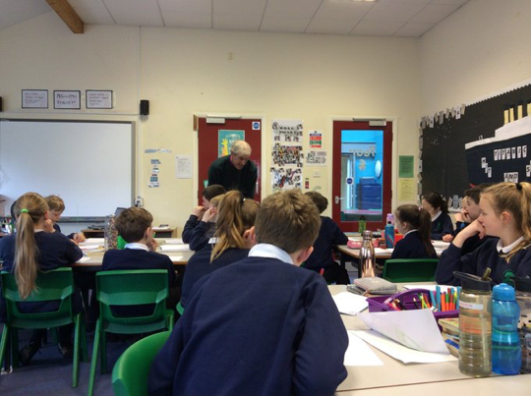

This is Bishop James with Y6.

