A visit to
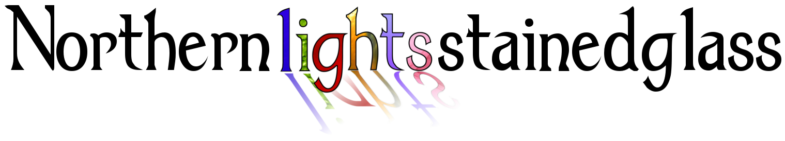
On Tuesday 14th January 2020 Faith, Anna and Lily went to the Northern Lights Stained Glass shop to look at their winning pictures for the Good Samaritan stained glass window.
At the shop, Sarah showed us what they have done with the designs and how they are making them.
Sarah showed us how they fuse glass, paint it and lead it, all as part of the process. We also saw the kiln.
We were very excited to see our designs coming to life and liked how Sarah explained everything.
Sarah showed us the stained glass work she has done in a portfolio and we were very impressed. They told us all about their biggest projects and the work in local churches.
Below is a sneak preview of our designs and some of the techniques.

